Airport Runaway Management System

Operating System

Project Proposal

BSCSev-V-C

Fall-25

Group Members
Muhammad Ahmad Ather 232400
Hameed Ur Rehman 232520
Shukran Badshah 233094

Submission Date
[23-11-2025]

Introduction
Airport runway operations are among the most critical real-time processes where both safety and efficiency are essential. Multiple aircraft request landing and takeoff, but limited runway resources require controlled access and proper scheduling. Failure to handle these operations efficiently can lead to delays, congestion, or even catastrophic accidents.
This project aims to simulate an airport runway management system using Operating System concepts such as semaphores, synchronization, and priority scheduling. The system will model planes as processes competing for access to a single runway. Emergency aircraft will be given higher priority and can preempt normal operations, mimicking real-world aviation protocols.

Objective of Project
The main objectives of our project are as follows:
- To simulate real-time runway scheduling using semaphores for controlled resource access.
- To implement priority scheduling where emergency planes can preempt ongoing operations.
- To model landing and takeoff queues with realistic timing constraints.
- To improve understanding of OS synchronization mechanisms in complex, concurrent environments.
- To create a user-friendly environment for visualizing aircraft queue behavior and scheduling decisions.

Abstract View
Our project simulates an airport environment where multiple planes arrive requesting either landing or takeoff. Each plane is treated as a process that must acquire the runway resource (protected by a semaphore) before performing its operation.
Planes are placed in queues—normal queue and emergency queue. A priority scheduling algorithm ensures that emergency landing requests always override normal operations. If an emergency plane arrives while another plane is waiting or currently using the runway, the emergency plane is scheduled first.
The system will display real-time information such as number of waiting planes, runway status, and the order of operations. This simulation demonstrates synchronization, concurrency control, and priority handling, which are essential in real operating systems.
Architectural Flow
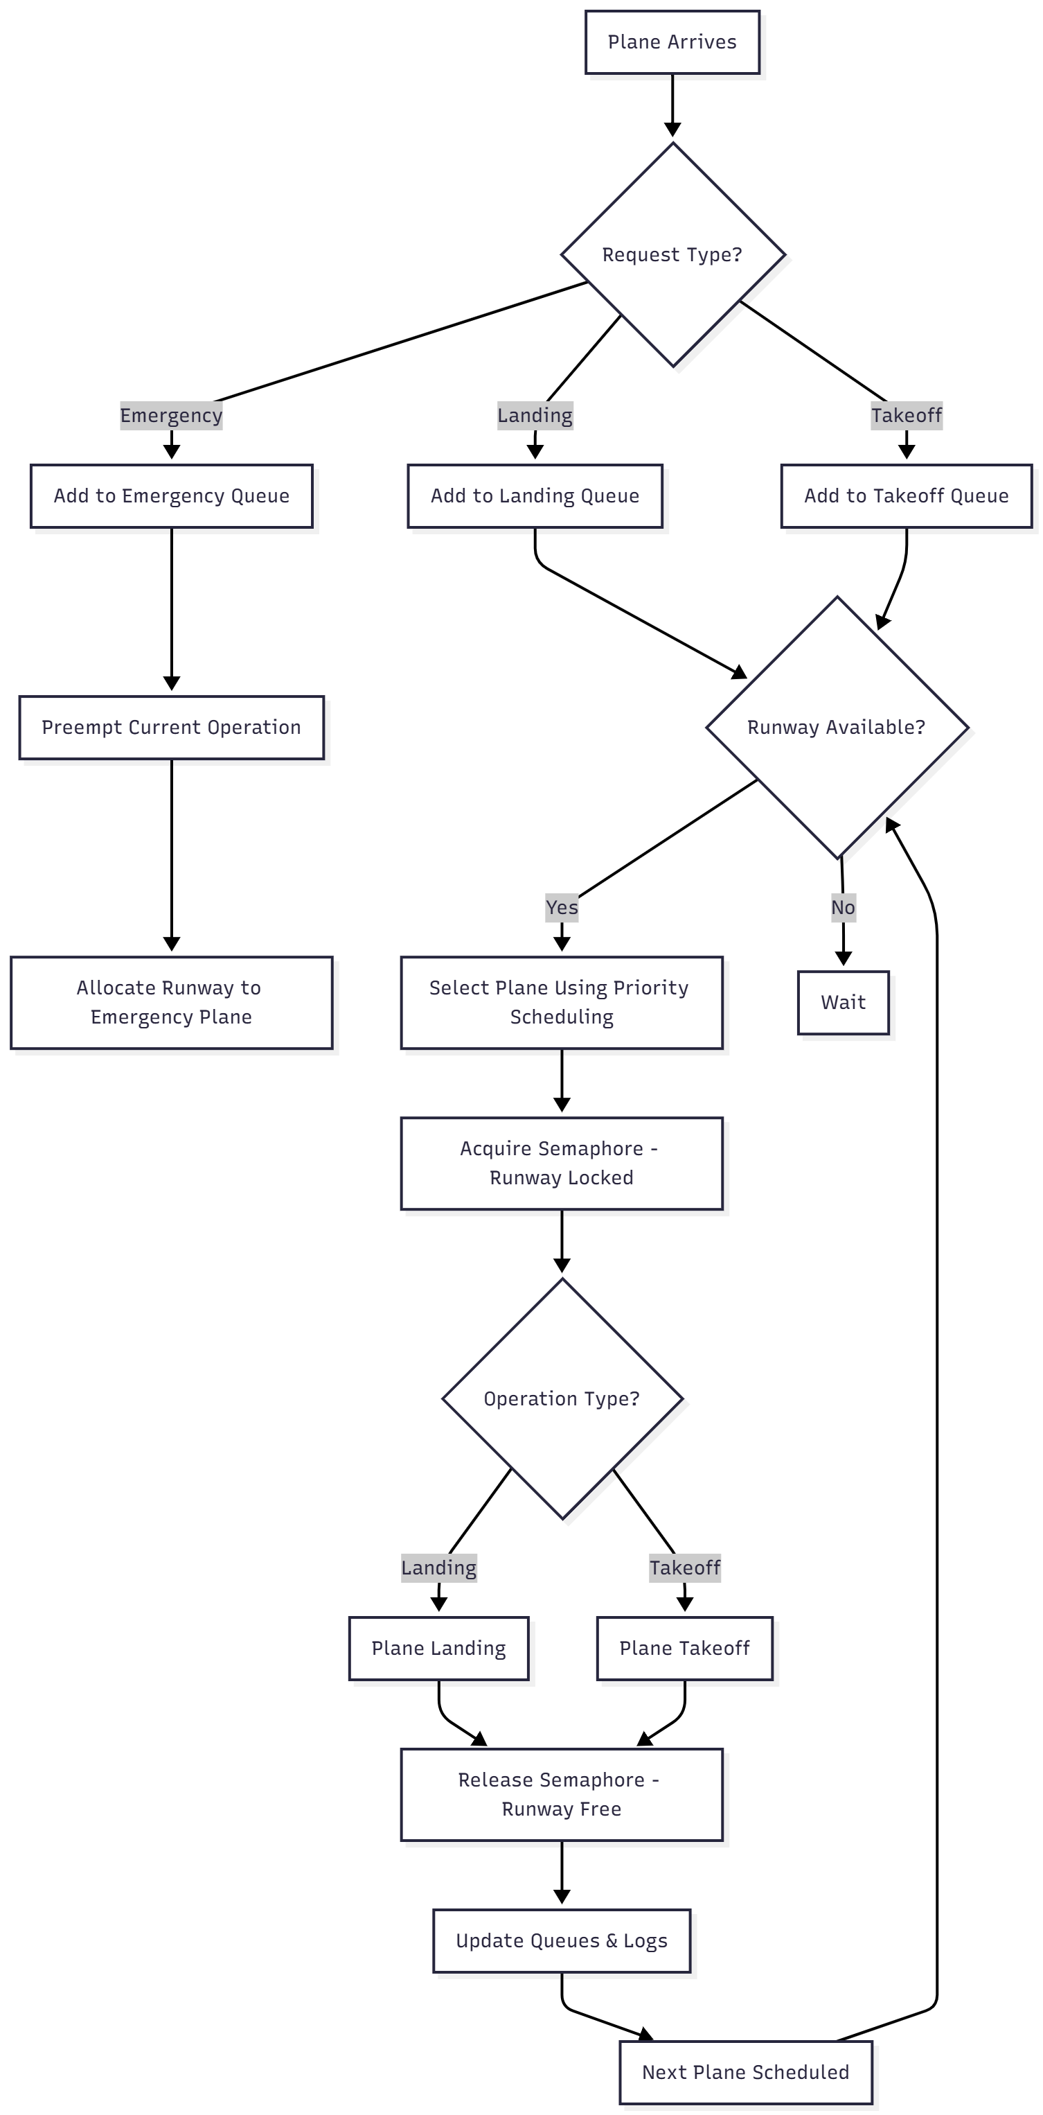

Key Responsibilities
Project Manager:
– Coordinates workflow, documentation, and project deadlines.
– Ensures integration of all modules.
Design Engineer:
– Designs system architecture, scheduling algorithm, and process flow diagrams.
– Works on UI/visual representation if required.
Technical Team / Developers:
– Implement semaphore-based runway control logic.
– Write code for queues, priority scheduling, and process simulation.
– Perform testing and debugging.
(You may assign these roles to specific group members as needed.)

Conclusion
This project will demonstrate how operating systems manage shared resources and handle processes with varying priority levels. By simulating real-world airport runway management, we will apply theoretical OS concepts—especially semaphores, concurrency, and CPU scheduling—to a practical scenario. The project will not only strengthen our understanding of OS internals but also help develop problem-solving and system-design skills.

References
[1]. https://www.geeksforgeeks.org/semaphores-in-operating-system
[2]. https://www.javatpoint.com/os-cpu-scheduling
[3]. https://www.faa.gov/air_traffic/publications

